To do Collisions between two rectangles, I got the coordinates of the bottom left and top right corners of the rectangles then tried set up if statements that would detach if they are overlapping. This didn’t work but it lead me to find .intersects which creates two rectangles around the objects then detects if they are overlapping.

This is the code that detects if two objects are overlapping. While it logically makes sense when I ran the code, if the character encountered an obstacle it would be teleported instead of pushed back. Changing the direction variable to a global fixed the problem.

This is the code that handles the moving animations. For movement I have 2 pictures in each direction that switch every 0.5 seconds to make it look like the character running.

Next I added attack pictures, I plan to give the sword its own hitbox then detect if it touches an enemy by using invisible rectangles that overlap with the position of the sword and move with the player.

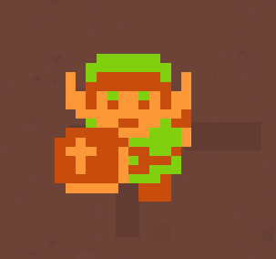Here you can see the rectangles around the player.

I also decided to add a timer to the sword animation changing it back to the direction the character is facing so the sword isn’t always out.

I also added a health aspect and a function to monitor and change it.

Full health – 6 Half health – 3

After I made a fixed map I ran into a problem where when you leave the current room the sword hitboxes don’t move with you, I fixe this by making a check time in the background that moves the swords relative to the character and not the characters movement.

This is what I made:

When you go through a door, the sword hit boxes will go to these locations.

Next I wanted to add sound effects. Using a book called “javafx for dummies” I discovered the MediaPlayer method which lead me to this make this code.

When you hold down the arrow keys to move it plays the walking sound every 0.4 seconds and when you release the key it stops. One problem I ran into is stopping the sound, at first, I tried to stop the mplayer but that would only stop the current sound then carry one. I then tried stopping the timeline which worked successfully.

I then made a dynamic array of images that I’m going to use to randomly generate items and enemies.

There is now one item in every room.

I also created a procedure called itemChanger that changes the visible item in each room.

It does this by getting the substring of the variable currentFloor and mating that to an array position.

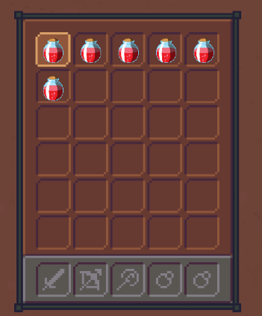

One problem I ran into is removing the item from the dynamic array when picked up. Using .remove deleted the position and the item in the next position took its place which was breaking it. A fix for this is just to make the item you pick up invisible and then create a new item in the inventory dynamic array which will set its x,y.

Next, im going to make it possible to use items. Pressing E which a health potion is selected will increase health by 2 and then remove it from the inventory.

After that I fixed a problem with how the map is constructed. This is the complete code for that:

Whenever the character touches a door, this procedure changes the background, doors, items and enemies to properly fit the next room.

To add enemies, I made a dynamic array and class that places an enemy in each room. To attack the enemies I made a procedure and had it called each time space is pressed.

Before a hit, opacity = 1. After one hit, opacity = 0.5 After two hits, opacity = 0

This is the movement code for the enemies. It uses translate transitions to move images over time.

I added some more sound effects to the soundManager

I then started to implement the boss.

I then added a collisions for the boss and a health bar.

Tio make the health I bar loaded into an image then overlapped a red rectangle that reduces in width when the boss is hit.

The boss after 4 hits.

As a reward for defeating the boss a chest will appear that contains the triforce which is an item made by the gods in the Zelda franchise.

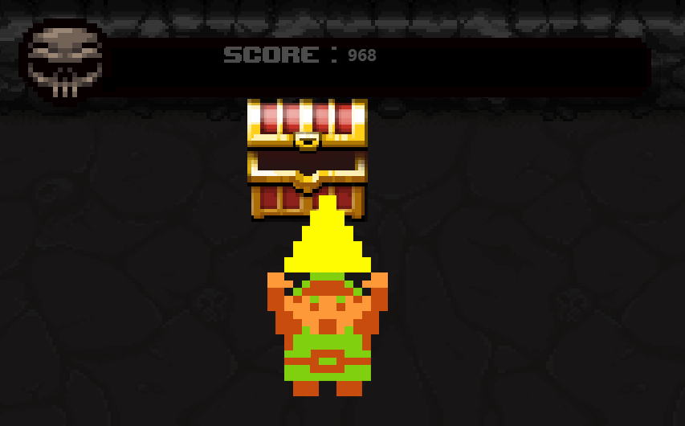

While testing the boss I found a bug to do with how the player attacks.

When swapping images the x and y coordinate align by the top left corner, this would be okay but when I was implementing the attacking images if you were to look up or left then press space It would align and push and character away but ideally you would take the character to stay in the same place and the sword move forward to hit the enemy. To fix this when you look up or left and press space to attack I change the coordinates of the character to make it appear the sword is moving out in the direction the character is looking and then change the coordinates back 1 second later. The problem I found with this is that you can look left or up and continually press space to seemingly teleport the player across the screen. To fix this I added a check that only moves the character if they aren’t already in the sword animation.

Before After

Adding on that issue, if the character is moves up or left while in the attack image for that direction it would teleport them 100 pixels in that direction because it skips the check above. To fix this I added a check when movement occurs in those directions.A screenshot of a cell phone

To make the character better equipped for the final boss and make use of the shop idea, I added a staff h=which will be a range attack that fires projectiles.

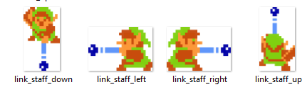

I first added that staff pictures to the attack handler to change the pictures when necessary

To use the staff you will first need to buy it from the shop using coins that enemies drop when defeated.

This is a picture of the shop and the shop keeper.

I then added that staff to the shop with a price of 3 coins

Once the staff is purchased it can be used with A,S,W and D keys to aim it. It then shoots out a ball of magic that will damage enemies.

This is the code that creates and moves the balls of magic

I then added functionality for the staff so it can damage enemies.

Then I added an if statement to the input manager so you can only use the staff once you’ve purchased it from the shop.

To add on to the boss fight, when the boss is defeated the Score will be saved to a sql database to create a scoreboard.

It worked.

As you can see when the boss is defeated the game successfully writes the name and Score to the dtatabase.

This is the code that writes to the database:

Because of user feedback I made a procedure that reads from the database and displays it all in order when the game starts.

The scoreboard disappears when the character first moves.

I then made a scoreboard image and overlapped it.

I plan to change this to a 2D array as a longer name will result in the Score being further to the right.

When I changes it to a 2D array of Labels, this was the result.

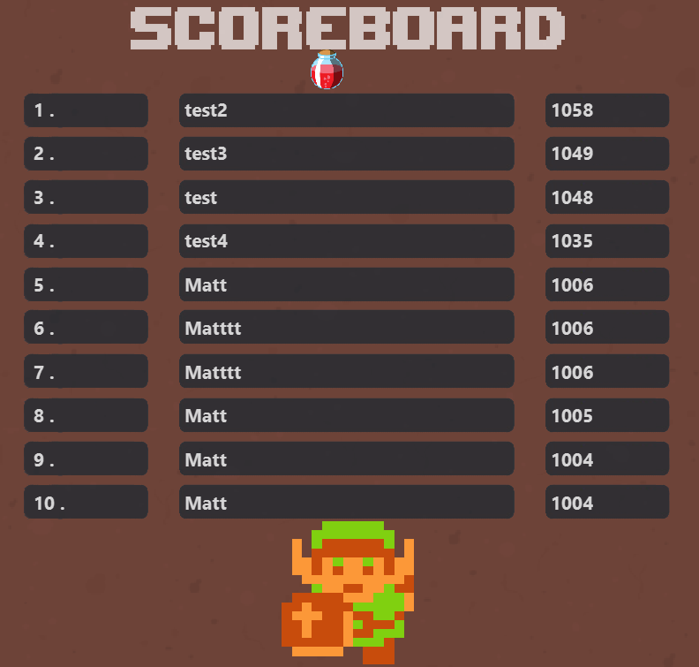

As you can see, the names and score line up much nicer as they are each given their own x and y coordinates and not separated by a lot of spaces.

I then did a small change that starts the Score countdown when you first move and not when the program first starts. This will give the player a chance to look at the leader board without the score plummeting.

While testing that the scoreSaver procedure worked, I realised a problem with how the enemies are attacked. Part of the enemyMover procedure is a timeline that checks if the enemy is in contact with the hero and then damage the player. The problem with this is that the first time you attack an enemy in any room, the player will take damage if you hit the enemy. To fix this I made a Boolean that tracks when the hero is in attacking and then add that to an if statement in the enemyMover procedure. Now the enemy cannot hurt the player if the player is attacking the enemy.

To add further functionality to the staff I added a sound effect that plays when the staff shots a projectile.

I also added a staff cooldown because previously you could shoot again as soon as the projectile makes contact with the enemy. Now when you shoot the projectile you can’t shoot it again for 2 seconds.

To animate enemies I added a .setImage method to the enemies class but when testing I came across a bug. To get the coordinates of the enemy in the room I would use .getlayoutX and .getlayoutY but these didn’t work on moving images which lead me to find .getTranslateX and .getTranslateY. A screenshot of a cell phone

When it came to animate the enemies it much harder than I anticipated; When I came to a solution the enemy could ‘see’ where you are and then act appropriately. To make the enemies ‘see’ I calculated the gradient between the enemy and the player and then depending on the gradient I know what part of the screen the hero was in.

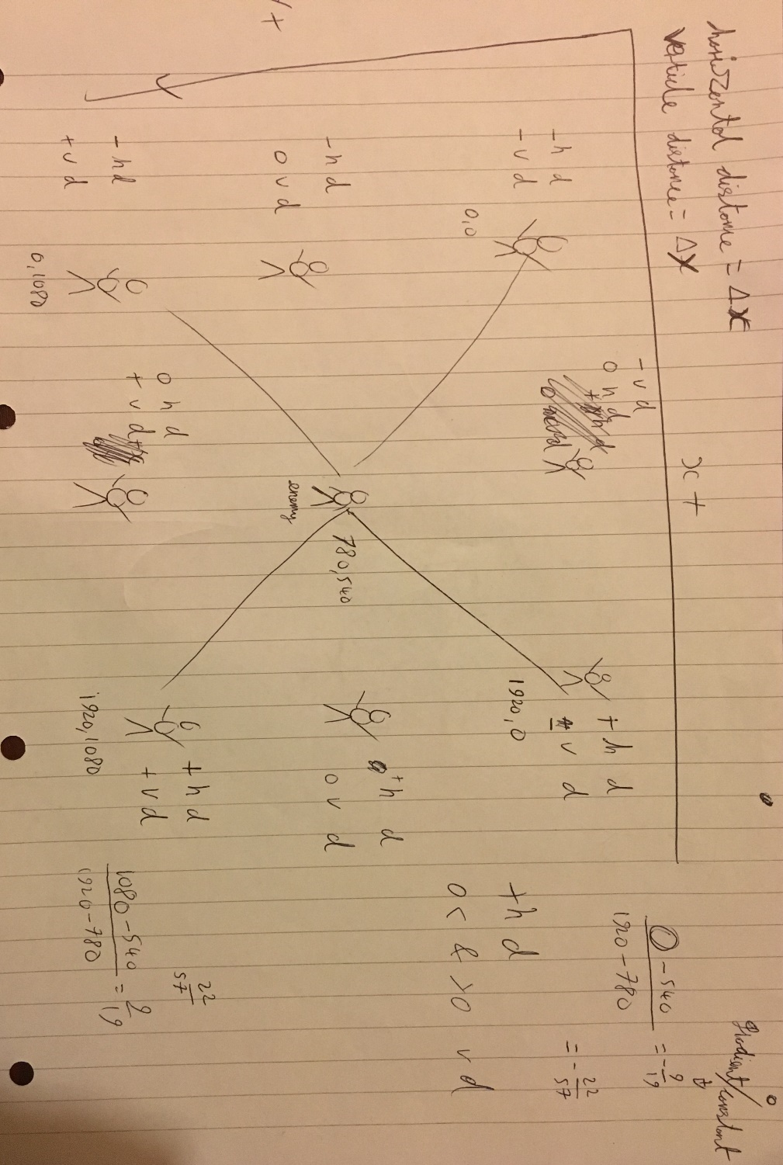

The main program uses 5 classes, 2 of which called Enemies and Images are very similar; because of this I made a base class for the other classes to inherit from.

This is my new base class:

This is my updated Enemies and Images class:

After creating the animating the enemies I realise a way to optimise the hero animation.

Before:

After:

It works just as well with less lines.

I then extended it to the Magic and Fireballs class to further optimise it.

I then make a Base Procedure to optimise the input manager.

Previously in each movement case all 9 statements above would be called. Now the Base Procedure is called instead.

I then decided to make a main menu for the game using scene transitions.

Code:

I took a picture from the game Cave blazers and used that as the background then I moved the text field and enter button from the post boss fight to this screen. When the button is pressed it only starts the game if the text field contains text. I then created an image that shows the games controls and added it to the menu as well. I also added the input manager so the controls can be brought back when i is pressed.

This is what the menu looks like:

I then added sound controls for the music and sound effects in the game.

While testing the mute function I realised when increasing the volume, it doesn’t affect the music currently playing e.g. when the game starts the background music starts on volume 1. Then if you turn the volume up to 10 everything will be 10x louder apart from the background music.

To do this I updated the music controls in the input manager: